waitForPageToLoad

To launch a batch file
Process batch = Runtime.getRuntime.exec("path of the batch file");
batch.waitFor();

read a JavaScript variable in Selenium WebDriver
// Initialize the JS object.
JavascriptExecutor JS = (JavascriptExecutor) webdriver;
// Get the current site title.
String sitetitle = (String)JS.executeScript("return document.title");
System.out.println("My Site Title: " + sitetitle);

Java -jar "C:\Selenium Webdriver Questions\selenium-server-standalone-2.33.0.jar" -htmlSuite "*firefox" "http://www.google.com" " “C:\Selenium Webdriver Questions\SeleniumSuite.HTML"
java -classpath ".;selenium-server-standalone-2.33.0.jar" SampleClass

https://www.techbeamers.com/selenium-webdriver-questions/
https://www.techbeamers.com/selenium-webdriver-interview-questions-test-engineers/
https://www.techbeamers.com/selenium-webdriver-cucumber-interview-questions/
https://www.techbeamers.com/latest-selenium-interview-questions-and-answers/
08232019 Selenium
Contents
POM 2
Properties c# 4
XPATH 5
Xpath loactors 5
Using xpath 5

POM
The main advantage of Page Object Model is that if the UI changes for any page, it don’t require us to change any tests, we just need to change only the code within the page objects (Only at one place).
Ex:
public class SignInPage {
private WebDriver driver;
Private By headerPageText = By.cssSelector(“.hidden-small”);
}
Page Object model is writing all the functionalities / reusable components of a page that we want to automate in a separate class.
"Within your web app’s UI there are areas that your tests interact with. A Page Object simply models these as objects within the test code. This reduces the amount of duplicated code and means that if the UI changes, the fix need only be applied in one place."
When ever we are navigating to other page, we need to return that page object. Else Return the current page object as this action doesn't navigate to a other page represented by another Page Object
Selenium Page Factory Pattern is like an extension to Page Object Model , but Page Factory is much enhanced model.
"Factory class can be used to make using Page Objects simpler and easier".
We should initialize page objects using initElements() method from PageFactory Class
Once we call initElements() method, all elements will get initialized. PageFactory.initElements() static method takes the driver instance of the given class and the class type, and returns a Page Object with its fields fully initialized.

HomePage homePage = new HomePage(driver); PageFactory.initElements(driver, homePage);
Or
HomePage homePage = PageFactory.initElements(driver, HomePage.class);
#or as a constructor
public HompePage(WebDriver driver) {
this.driver = driver;
PageFactory.initElements(driver, this);
}
An exception will be thrown if the class cannot be instantiated.
Page Factory will initialize every WebElement variable with a reference to a corresponding element on the actual web page based on “locators” defined. This is done by using @FindBy annotations.
Annotations are used to give descriptive names for WebElements to improve code readability. And annotation @FindBy is used to identify Web Elements in the page.
The @FindBy annotation supports all the other locators strategies that we use:
id, name, className, css, xpath, tagName, linkText and partialLinkText
@FindBy(how = How.ID, using = "username")
private WebElement userName;
Or
@FindBy(id="username")
private WebElement userName;
Or
@FindBy(className=".input.username")
private WebElement userName;
Or
@FindBy(tagName = "mylist")
private List<WebElement> links;
Or
@FindBy(name="username")
@CacheLookup
private WebElement userName;
lazy initialization is the tactic of delaying the creation of an object, the calculation of a value, or some other expensive process until the first time it is needed.
There are some other advantages, such as additional annotations like:
@FindBy(name = "q")
@CacheLookup
private WebElement searchBox;
That @CacheLookup makes the lookup for the element happen just once. After that, it will be cached in the variable and accessible much faster.

CacheLookup attribute can be used to instruct the InitElements() method to cache the element once its located and so that it will not be searched over and over again – this is useful when the elements that are always going to be there
But whenever we use @CacheLookup annotation, we will be losing one of the page factory benefit as it will find the element once and then keep a reference to it, hence, we are more likely to see StaleElementExceptions.
The page object pattern simply abstracts business logic away from the physical structure of the pages.

Parallel execution
https://www.seleniumeasy.com/selenium-tutorials/parallel-execution-in-selenium-grid

To access from the App.config
public static string CashReceiptCreateUrl { get; private set; } =
ConfigurationManager.AppSettings.Get("CashReceiptCreateUrl");

Properties c#

https://docs.microsoft.com/en-us/dotnet/csharp/programming-guide/classes-and-structs/properties

https://docs.microsoft.com/en-us/dotnet/csharp/programming-guide/classes-and-structs/restricting-accessor-accessibility

XPATH

Xpath loactors
Id,classname,name,link text, xpath, css path

XPath(XML path) is used to find the location of any element on a webpage using HTML DOM structure.
Xpath = //(current node)tagname(input,div,img)[@(selects attribute)Attribute(attribute name)=’value’(value of the attribute)]
Xapth= //tagname[@Attribute=’Value’]
Relative Xpath the path starts from the middle of the HTML DOM structure. It starts with the double forward slash (//), which means it can search the element anywhere at the webpage.

XPath axes search different nodes in XML document from current context node. XPath Axes are the methods used to find dynamic elements, which otherwise not possible by normal XPath method having no ID, Classname, Name, etc.
Axes methods are used to find those elements, which dynamically change on refresh or any other operations. There are few axes methods commonly used in Selenium Webdriver like child, parent, ancestor, sibling, preceding, self, etc.

Using xpath
- Basic Xpath
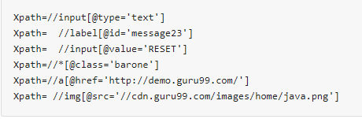
- Contains()
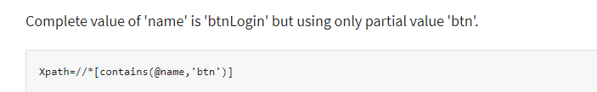
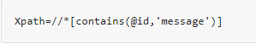
//*[contains(text(), ‘xyz’)]

- Using OR & AND
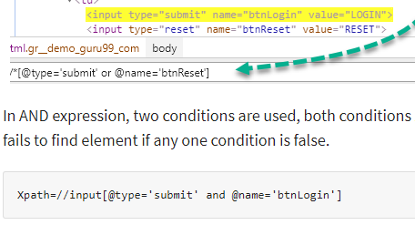
- Start-with function
If ID
Id=" message12"
Id=" message345"
Id=" message8769"
and so on.. but the initial text is same. In this case, we use Start-with expression.
//label[starts-with(@id,’message’)]
- Text()
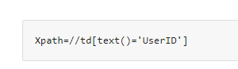
- XPath axes methods: find the complex or dynamic elements.
  - Following - Selects all elements in the document of the current node( ) [ UserID input box is the current node] as shown in the below screen.
  - 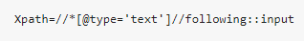
  - 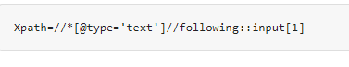
  - Ancestor: The ancestor axis selects all ancestors element (grandparent, parent, etc.) of the current node
  - 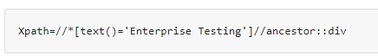
  - 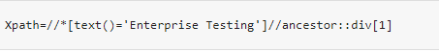
  - Child: Selects all children elements of the current node
  - 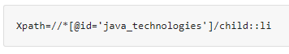
  - 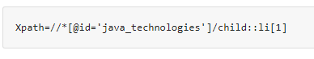
  - Preceding: Select all nodes that come before the current node
  - 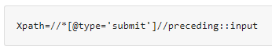
  - 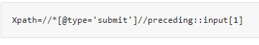
  - Following-sibling: Select the following siblings of the context node. Siblings are at the same level of the current node
  - 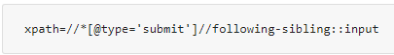
  - Parent: Selects the parent of the current node
  - 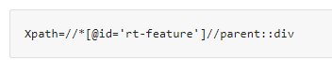
  - 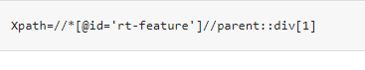
  - Self: Selects the current node or 'self' means it indicates the node itself
  - 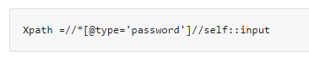
  - Descendant: Selects the descendants of the current node
  - 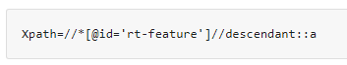
  - 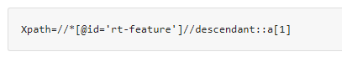

NUNIT
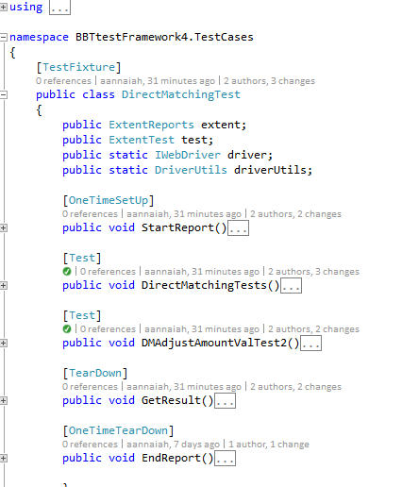

XUNIT
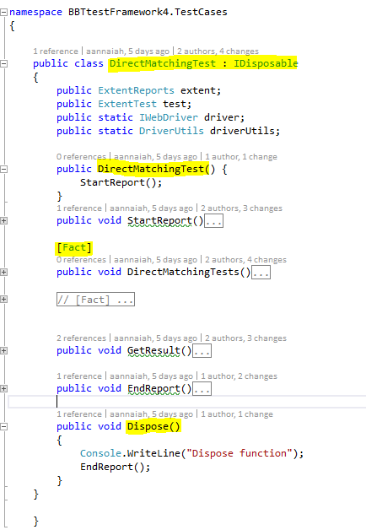

Questions
If we remove parameter (int x) or we remove @override, the program compiles fine.

Annotations in Java
Annotations are used to provide supplement information about a program.
- Annotations start with ‘@’.
- Annotations do not change action of a compiled program.
- Annotations help to associate metadata (information) to the program elements i.e. instance variables, constructors, methods, classes, etc.
- Annotations are not pure comments as they can change the way a program is treated by compiler. See below code for example.

/* Java program to demonstrate that annotations are
not barely comments (This program throws compiler
error because we have mentioned override, but not
overridden, we haver overloaded display) */
class Base
{
public void display()
{
System.out.println("Base display()");
}
}
class Derived extends Base
{
@Override
public void display(int x)
{
System.out.println("Derived display(int )");
}

public static void main(String args[])
{
Derived obj = new Derived();
obj.display();
}
}
10: error: method does not override or implement
a method from a supertype
https://www.geeksforgeeks.org/annotations-in-java/

How ? QCWorkAllocationScreen.CurrentUrl
%TEMP%\VisualStudioTestExplorerExtensions

4009614 90154540

alternate to sleep ?

//Call executeAsyncScript() method to wait for 5 seconds
js.executeAsyncScript("window.setTimeout(arguments[arguments.length - 1], 5000);");

js.executeScript("alert('Welcome to Guru99');");

JavaScriptExecutor.ExecuteClickScript("arguments[0].click();", checkbox);

4010249_530535_Electronic

SpecFlow
SpecRun.SpecFlow.2-4-0
Specrun.Specflow

https://specflow.org/documentation/Generate-Tests-from-MsBuild/

guru99
GIT- > Jenkins
need a mechanism by which our two different executions should not overlap with each other. This can be achieved using Session Handling in Selenium.
create a new instance of a WebDriver object, a new 'sessionId' will be generated and attached with that particular Firefox/Chrome/IE Driver ().(is an in-built functionality)

run Parallel Tests with Selenium (testng.xml)<?xml version="1.0" encoding="UTF-8"?>
<!DOCTYPE suite SYSTEM "http://testng.org/testng-1.0.dtd">
<suite name="TestSuite" thread-count="3" parallel="methods" >
<test name="testGuru">
<classes>
<class name="TestGuru99MultipleSession">
<include value="testGuru99TC1" dependsOnMethods=" testGuru99TC2"/>
<include value="testGuru99TC2"/>
</class>
</classes>
</test>
</suite>
one can use "parallel" attribute
instances: Test cases in same instance will execute parallel but two methods of two different instances will run in different thread.
The attribute thread-count allows you to specify how many threads should be allocated for this execution.

You can set order and dependency of Test Case execution - we will use 'dependsOnMethods' attribute to make dependency and order of execution.

AutoIT
Use the IDE to develop the .exe file
and use the Runtime class allows the script to interface with the environment in which the script is running.
getRuntime() get the current runtime associated with this process.
exec() methods execute the AutoIT script ( FileUpload.exe )
Runtime.getRuntime().exec("E:\\AutoIT\\FileUpload.exe");

IASC.BBT.UI.Automation.API/IASC.BBT.UI.Automation.API/Controllers/DBSStatementController.cs31
31. return null

IASC.BBT.UI.Automation.API/IASC.BBT.UI.Automation.Services/CPSStatementService.cs
30 use return statementId instead of statusid

IASC.BBT.UI.Automation.API/IASC.BBT.UI.Automation.Services/DBSStatementService.cs
29 use return statementId instead of statusid

POC for BDD and Cucumber based Test Automation Framework

Table of Contents

Purpose 2
Project for barebones QA Automation Testing using: 2
What is BDD? 3
How Can I write tests without actual code? 4
Advantages: 5
Demo: 5
Summary: 6

Purpose
To create Test suite for Regression tests in CRC- CPS application giving maximum test coverage using the BDD approach.

Project for barebones QA Automation Testing using:

- Selenium – It is a portable framework for testing web applications.
- C# - Programming language used to write test script
- SpecFlow - SpecFlow is the open source port of Cucumber for .NET. Define automatic tests in Gherkin and execute them using xUnit.
- Cucumber - A cucumber is a tool based on Behavior Driven Development (BDD) framework which is used to write acceptance tests for the web application.
- Gherkin - Gherkin is a Business Readable, Domain Specific Language created especially for behavior descriptions. It gives you the ability to remove logic details from behavior tests.
- Xunit - xUnit.net is a free, open source, community-focused unit testing tool for the .NET Framework.
- Page Object Model Design Patten - It is widely used design pattern in Selenium for enhancing test maintenance and reducing code duplication.

What is BDD?

- BDD keeps Business Behavior in sync with Software Development
- Extends Test Driven Development to cover Business Acceptance Tests

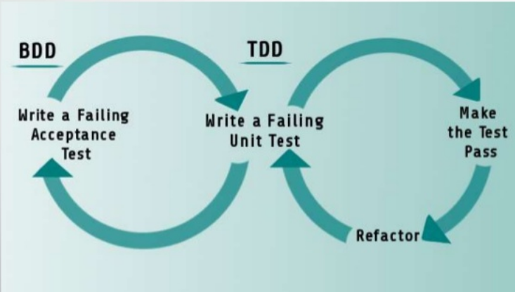

How Can I write tests without actual code?

- BDD uses Simple English Syntax – Gherkin
- BDD uses example based ‘Scenarios’
- Each ‘Scenario’ is noted in the form of ‘Given’, ’When’, ’Then’
Feature file:
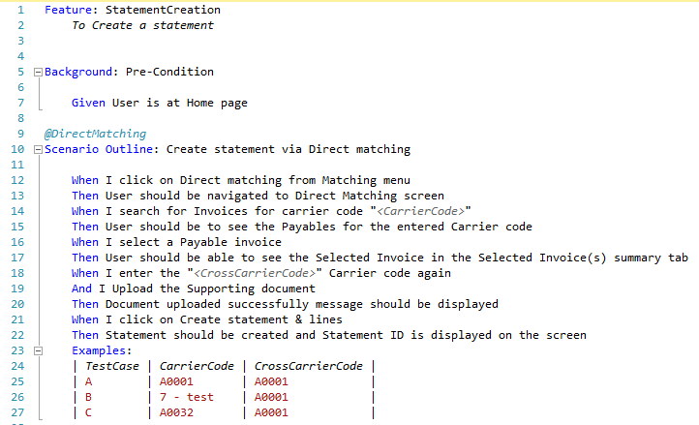
Step Definitions:
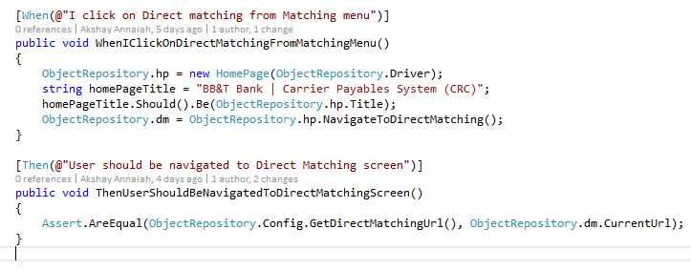

Advantages:

- BDD allows building on top of existing scenarios easily.
- Existing step-definitions can be re-used, only the new steps need to be written.
- Less Code Repetition – better regression framework.

Demo:
- Statement creation via Direct Matching
- Source Code : http://bhmtfsapp02:8080/tfs/crcinscollection/CRC%20_CPSDBS/_git/iasc-crc-automation?version=GBmaster&_a=contents

Summary:

- BDD minimizes communications, hides implementation details and provides robust regression tests.
- BDD provides Building Blocks of scenarios and step definitions, so incremental test can be written easily.

PyDev

Is the python development env for eclipse

